**Trendify E-Commerce Website**

MAJOR PROJECT REPORT

Submitted by:

**FAIZAN ALI JAFARI**

**2020-301-036**

In the partial fulfillment for the award of the degree of

**Bachelor of Computer Application**

Under the supervision of

**Mr. Faraz Doja**

**Department of Computer Science & Engineering**

**School of Engineering Science and Technology**

**JAMIA HAMDARD**

**(**Deemed to be University**)**

**New Delhi - 110062**

**2023**

DECLARATION

I, **Mr. Faizan Ali Jafari** a student of **BCA Enrolment No: 2020-301-036** hereby declare that the dissertation entitled **Trendify An E – Commerce website** which is being submitted by me to the Department of Computer Science & Engineering, School of Engineering Sciences & Technology, Jamia Hamdard, New Delhi in partial fulfillment of the requirement for the award of the degree of **BCA** is my original work and has not been submitted anywhere else for the award of any Degree, Diploma, Associateship, Fellowship or other similar title or recognition.

**(Signature and Name)**

**Date:**

**Place:**

**ACKNOWLEDGMENT**

I would like to express my sincere thanks to Mr. Faraz Doja, my project supervisor, for his invaluable guidance and support in the development of Trendify, an e-commerce website. His expertise and insights have been crucial in shaping my understanding of e-commerce and helping me to build a functional and user-friendly website.

I would also like to thank the faculty and staff of Jamia Hamdard for providing me with the resources and facilities needed to carry out this project. Additionally, I extend my gratitude to my fellow students for their feedback and support throughout the development process.

Finally, I would like to acknowledge the contributions of my friends, who provided me with and support throughout the project. Without their support, this project would not have been possible.

(Signature)

TABLE OF CONTENTS

|  |  |  |
| --- | --- | --- |
| **S.NO** | **TOPIC** | **PAGE NO.** |
| 1. | **DECLARATION** | 2 |
| 2. | **CERTIFICATE** | 3 |
| 3. | **ACKNOWLEDGEMENT** | 6 |
| 4. | **ABSTRACT** | 7 |
| 5. | **TITLE** | 8 |
| 6. | **CHAPTER-1 INTRODUCTION** | 9 |
| 7. | **CHAPTER-2 RESEARCH AND METHODOLOGY** | 11 |
| 8. | **CHAPTER-3 SYSTEM REQJIREMENT SPECIFICATIONS** | 13 |
| 9. | **CHAPTER-4 SNAPSHOTS** | 15 |
| 10. | **CHAPTER-65CONCLUSION** | 27 |
| 11. | **CHAPTER-7 LIMITATIONS AND FUTURE SCOPE** | 29 |
| 12. | **CHAPTER-8 REFRENCES** | 31 |

TABLE OF FIGURES

|  |  |  |
| --- | --- | --- |
| **S.NO** | **TOPIC** | **PAGE NO.** |
| 1. | **Home Page** | 15 |
| 2. | **Shop Page** | 18 |
| 3. | **Individual products Page** | 19 |
| 4. | **Blogs Page** | 21 |
| 5. | **Contact Us Page** | 23 |
| 6. | **Get In Touch** | 24 |
|  |  | 25 |
|  |  |  |
|  |  |  |
|  |  |  |
|  |  |  |

ABSTRACT

Trendify is an e-commerce website that offers a wide range of clothing options for both men and women. The website is visually appealing and easy to use, providing a simple user interface that allows customers to easily navigate through the product catalog. Although the website does not have a proper backend system or payment system in place, these limitations will be addressed in the future to enhance the user experience. In addition, the website will include a proper login page and a product preview option to further improve the customer experience. The implementation and results of the website have been successful, and the future scope includes the addition of new pages, payment and shipping facilities, and an improved backend system for storing data. The limitations of the current website provide opportunities for improvement, and the future scope will address these limitations to further enhance the functionality and user experience of the Trendify e-commerce platform. The development of Trendify was guided by the mentorship of Mr. Faraz Doja, and resources such as YouTube, W3schools, and Formsubmit were utilized to learn HTML, CSS, and JavaScript. Overall, Trendify provides a visually appealing and user-friendly platform for customers to purchase clothing online, with potential for further expansion and improvement in the future.

TITLE

Trendify - An E-commerce Website

This documentation serves as a comprehensive guide to Trendify, an e-commerce website that offers a wide range of products for both men and women. The documentation covers all aspects of the website, including its architecture, design, implementation, and future scope. The document provides a detailed description of the website's features, functionalities, and user interface, as well as the methodologies used to develop and test the website. Additionally, the documentation includes a list of references and resources used during the development of the website. By providing a detailed overview of the website, this documentation aims to assist users in understanding the website and utilizing its features to their fullest potential.

OBJECTIVE

The objective of Trendify, an e-commerce website, is to provide customers with a visually appealing, user-friendly platform to browse and purchase products. The website aims to offer a large number of products for both men and women and provide customers with a seamless shopping experience. The primary objective of Trendify is to make online shopping easy and convenient for customers, providing them with a wide range of products to choose from and making the purchasing process simple and hassle-free. Additionally, the website aims to offer secure payment and shipping facilities to ensure that customers have a safe and secure shopping experience. By achieving these objectives, Trendify strives to become a go-to platform for customers looking for a reliable and easy-to-use e-commerce website.

**CHAPTER-1**

INTRODUCTION

Online shopping has revolutionized the way people shop, and it has become increasingly popular over the past decade. The convenience and ease of access to a wide range of products have made online shopping a preferred choice for many consumers. Trendify is an e-commerce website that caters to both men and women with a large selection of trendy and fashionable clothing. With its visually appealing interface and simple user interface, Trendify aims to provide an enjoyable and seamless shopping experience to its customers.

The benefits of online shopping are numerous, and Trendify leverages them to provide its customers with a hassle-free shopping experience. Firstly, customers can browse through a large selection of products in the comfort of their homes or offices, saving time and energy. Trendify offers a diverse range of clothing options, including formal wear, casual wear, and accessories, making it a one-stop-shop for all your fashion needs. Additionally, Trendify frequently updates its inventory with new products to stay on top of the latest fashion trends.

Secondly, online shopping allows customers to compare prices easily and make informed purchase decisions. With Trendify, customers can easily compare the prices of similar products, read reviews, and make purchases with just a few clicks. This makes the shopping experience more transparent and convenient for customers.

Thirdly, Trendify offers an easy returns policy, ensuring that customers are satisfied with their purchases. The website also provides multiple payment options, including debit and credit cards, net banking, and cash on delivery, making it accessible to a wide range of customers.

In conclusion, Trendify is an e-commerce website that aims to provide a seamless and enjoyable shopping experience to its customers. With its visually appealing interface, large selection of products, and easy-to-use interface, Trendify is a great option for customers looking for trendy and fashionable clothing. The convenience of online shopping, easy returns policy, and multiple payment options make Trendify an ideal choice for customers.

PROBLEM STATEMENT

In the current market scenario, there is a high demand for e-commerce websites that offer a wide range of products and a user-friendly platform for customers to browse and purchase products. However, many e-commerce websites face challenges in terms of providing a visually appealing interface, a large number of products, and a simple purchasing process. These challenges can lead to a loss of customers and revenue for businesses. Additionally, security concerns related to payment and shipping can also be a major deterrent for customers to use e-commerce websites. To address these challenges, the Trendify website aims to offer a visually appealing and simple user interface with a large number of products for browsing and purchase. By addressing these issues, Trendify aims to become a reliable and go-to platform for customers looking for an easy and secure shopping experience.

**CHAPTER-2**

**RESEARCH AND METHODOLOGY**

The development of the Trendify website required thorough research and the use of appropriate methodologies. The website was designed to provide a smooth and enjoyable shopping experience for its users. It was developed using various technologies, including HTML, CSS, and JavaScript.

To begin the process of building the website, we conducted research on current web design trends and analyzed the design aesthetics of successful e-commerce websites. This helped us to identify the best practices for creating a visually appealing and user-friendly website.

We then started with the development of the website by creating the basic structure using HTML. We used HTML5, the latest version of HTML, which is optimized for modern web development and provides a wide range of features such as multimedia support, improved accessibility, and semantic markup.

HTML, which stands for Hypertext Markup Language, is the standard language used for creating web pages. It provides a structure for web content by using elements such as headings, paragraphs, and images. HTML plays a critical role in creating the structure and layout of the Trendify website. It provides a platform for organizing and presenting the website's content, making it easier for users to navigate and find what they need.

After the structure was in place, we added styling and visual elements to the website using CSS. We used CSS3, which provides a wide range of styling options such as animations, transitions, and gradients, to enhance the user experience and make the website more engaging.

CSS, which stands for Cascading Style Sheets, is used to define the visual appearance of a web page. It allows developers to create different styles and layouts for web pages, including fonts, colors, and positioning. CSS played a vital role in the development of the Trendify website by providing a consistent and appealing visual design for the website. It ensured that the website was visually appealing, easy to navigate, and user-friendly.

We also used JavaScript to add interactive features to the website, such as dynamic content, pop-ups, and drop-down menus. JavaScript allows for a more dynamic and engaging website by enabling real-time responses to user actions, making the website feel more responsive and user-friendly.

JavaScript, on the other hand, is a programming language used to add interactivity and dynamic behavior to web pages. It allows developers to create interactive features such as drop-down menus, pop-ups, and form validation. JavaScript played a significant role in the development of the Trendify website by enabling the creation of various interactive features that improved the website's functionality and user experience.

The research and methodology used in building the Trendify website also involved market research and user analysis. The website was designed to meet the needs and preferences of its target audience. User research was conducted to determine the features and functionalities that users would like to see on the website. This information was used to guide the development of the website, ensuring that it met the needs and preferences of its target audience.

Furthermore, the website was developed using an iterative process that involved continuous testing and feedback. This approach allowed the developers to identify and address any issues or errors in the website's design and functionality. It also allowed for the incorporation of user feedback and suggestions into the website's design, ensuring that it met the needs of its target audience.

**CHAPTER-3**

SYSTEM REQUIREMENT SPECIFICATION

1. **System Hardware Requirements:**

The Trendify website requires a computer or mobile device with an internet connection and a web browser installed. The website has been designed to be compatible with major web browsers such as Google Chrome, Mozilla Firefox, and Microsoft Edge. The minimum system requirements for the website include a device with a processor speed of at least 1 GHz, 1 GB of RAM, and a display resolution of 1024x768 or higher.

1. **System Software Requirements:**

The website can run on various operating systems such as Windows, Mac OS, Linux, Android and IOS

For runtime environment, this website requires visual studio code to run the HTML, CSS, Javascript code

1. **Functional Requirements:**
   1. **User coordination**

To coordinate with the user, the website uses forms.

A user can fill in his/her details including name, email, phone Number. Through these details, the owner will be able to contact with the customers

1. **Non-Functional Requirements**
   1. **Performance**

The website will be designed to provide a fast and responsive user experience, with page load times that are as short as possible. The website will be optimized for performance on a variety of devices and platforms, and will be able to handle a large number of concurrent users.

**4.2 Usability**

The website will be designed to be easy to use and navigate, with clear and intuitive menus and search functionality. The website will also be designed to be visually appealing and engaging, with high-quality product images and descriptions.

5. **Constraints and Assumptions**

**5.1 Technology Constraints**

The website will be built using HTML, CSS, JavaScript, and will run on windows. The website will be designed to be compatible with modern web browsers, including Google Chrome, Mozilla Firefox, Apple Safari, and Microsoft Edge.

5.2 **Operational Constraints**

The website will require an internet connection to function properly, and will be subject to the limitations of the user's internet connection and device capabilities. The website will also require ongoing maintenance and support to ensure that it remains secure, reliable, and up-to-date.

**CHAPTER-4**

SNAPSHOTS

**Home page**

The pictures below shows the home page of the website which includes banners and featured products along with new arrivals

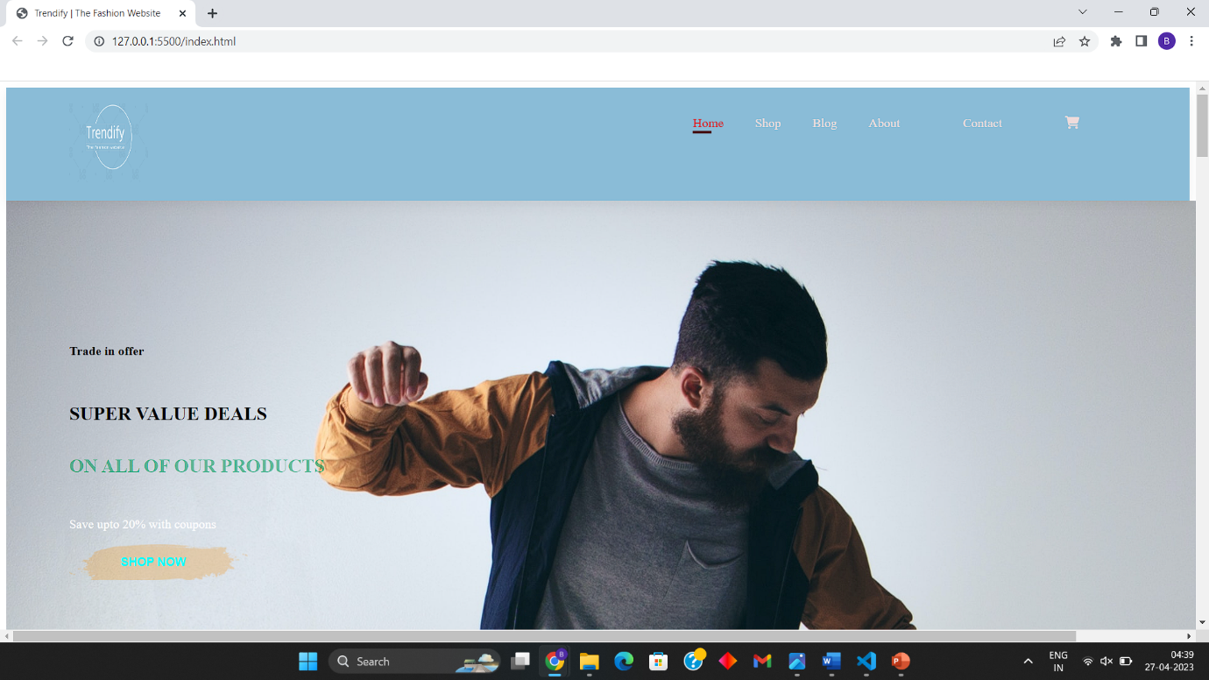

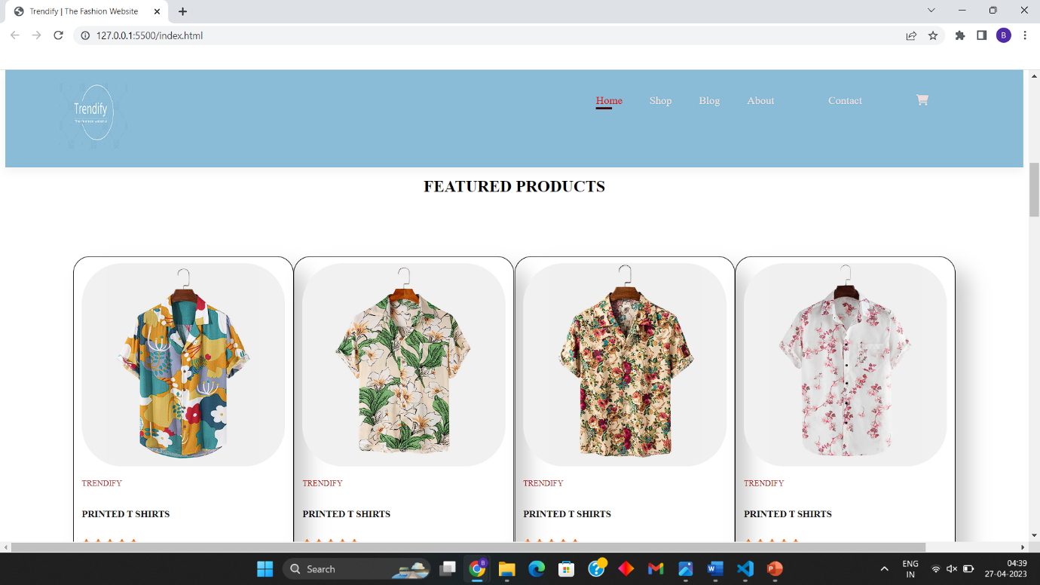

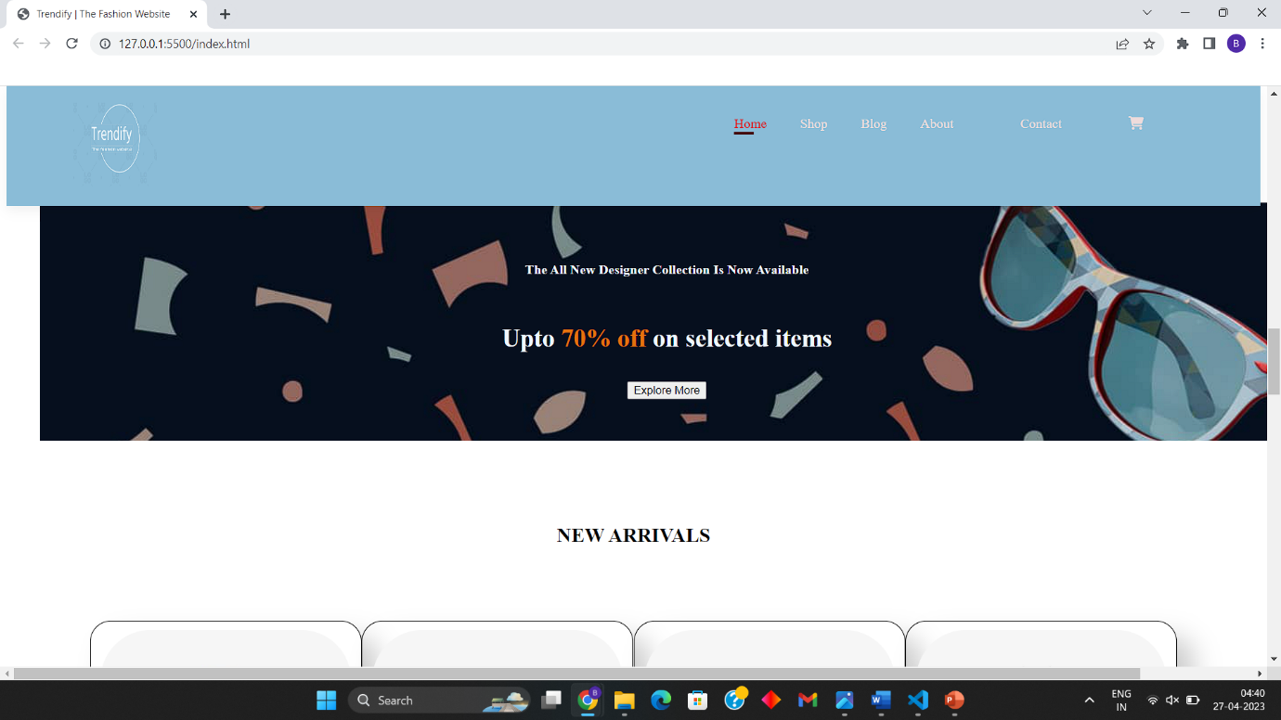

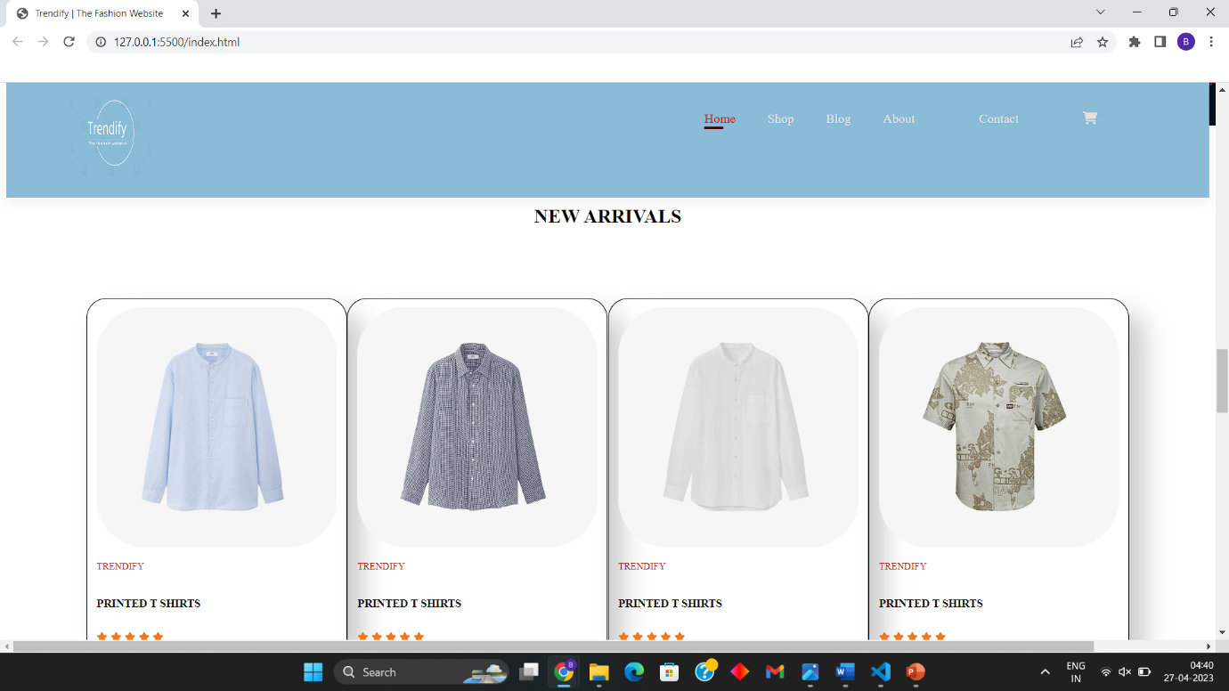

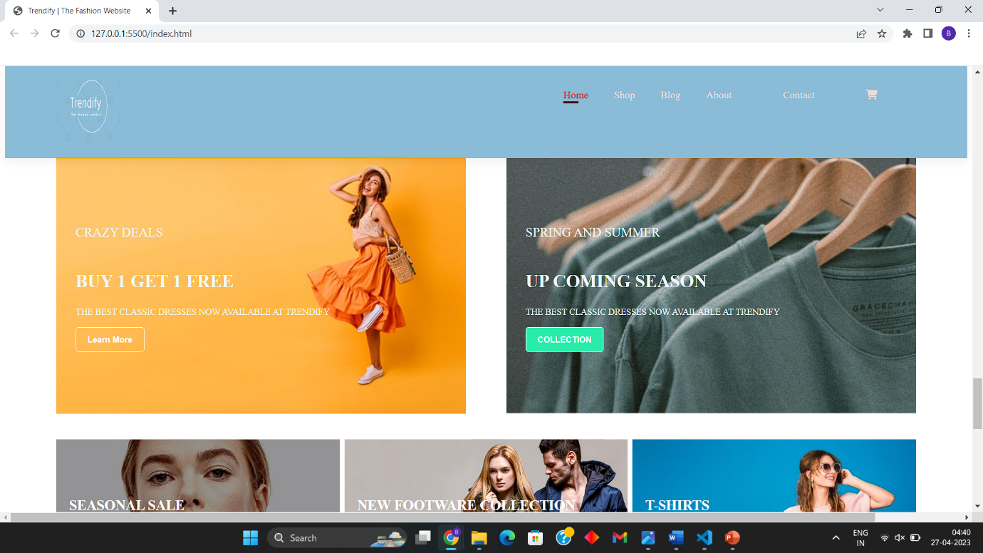

In the image below is the footer section of the website which include some necessary details.

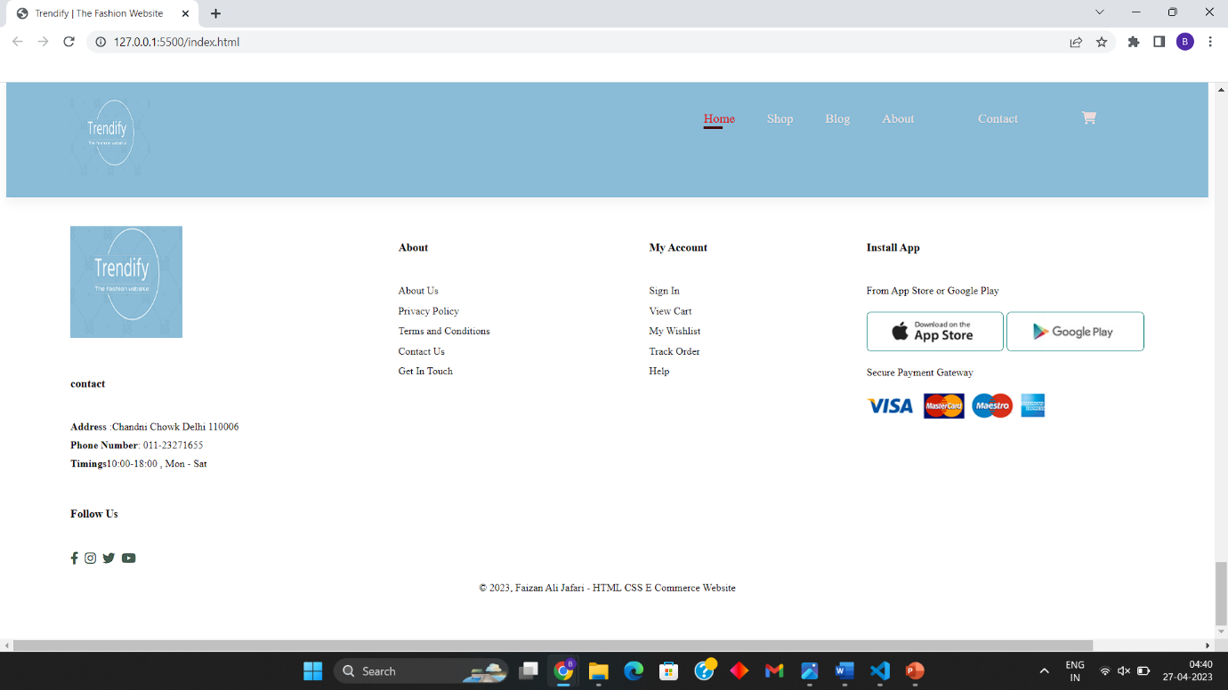

**Shop Page**

The images below show the Shop Page which includes all the products

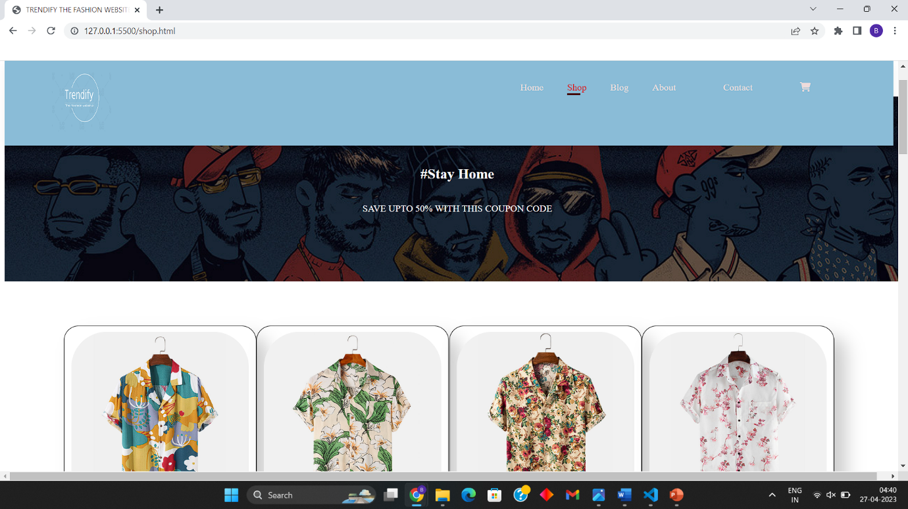

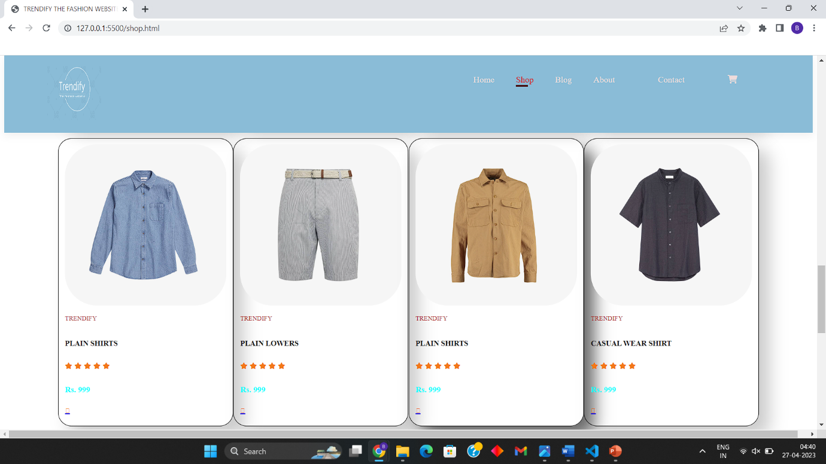

**Individual Product Page**

The images below shows the Individual products page from which the consumer will be able to see all the variations of a particular product.

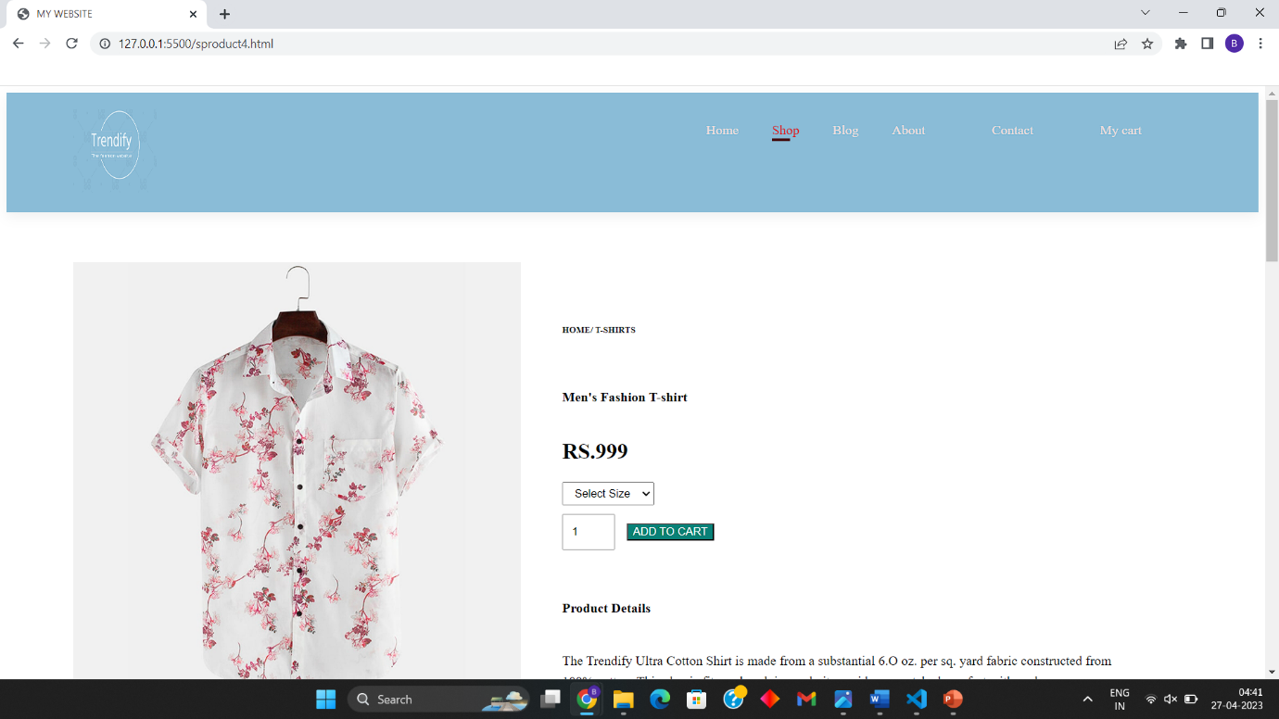

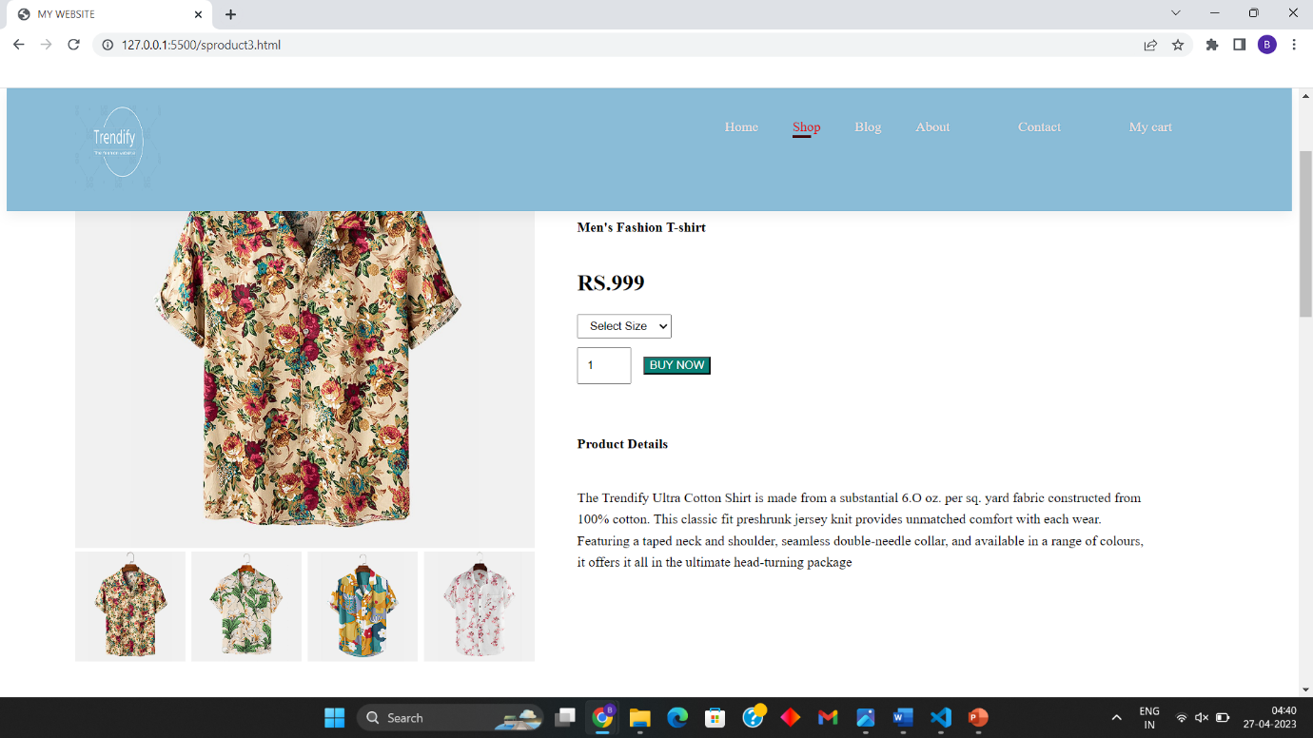

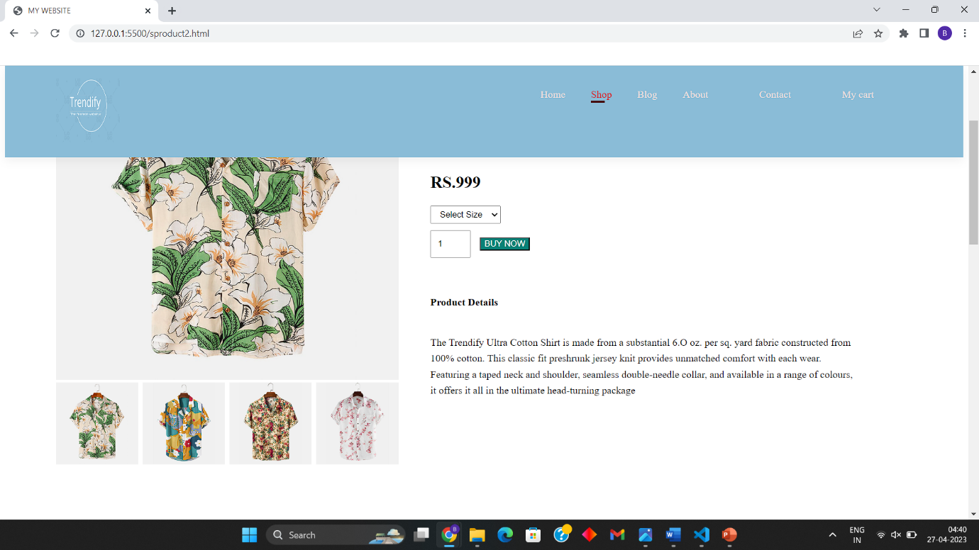

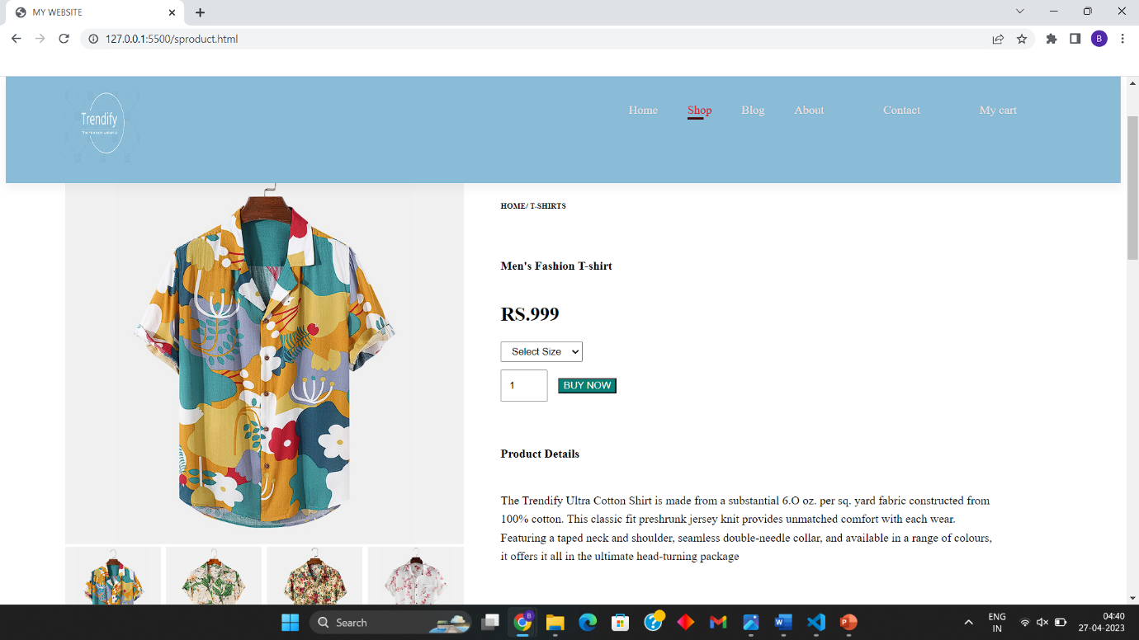

**Blogs Page**

The image below shows the blogs page through which the owner of the website can post blogs telling the customer about new products

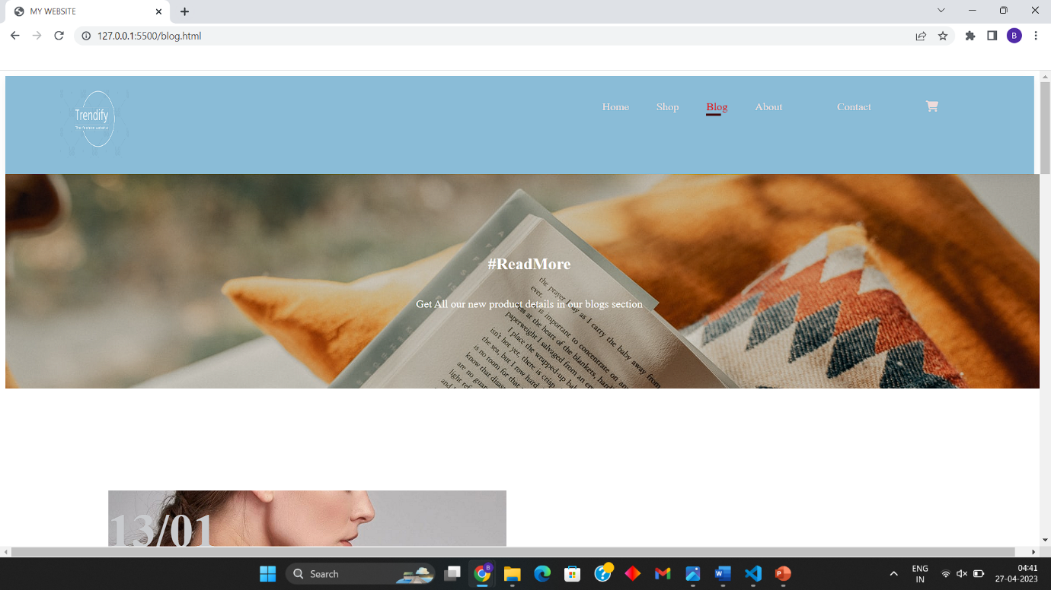

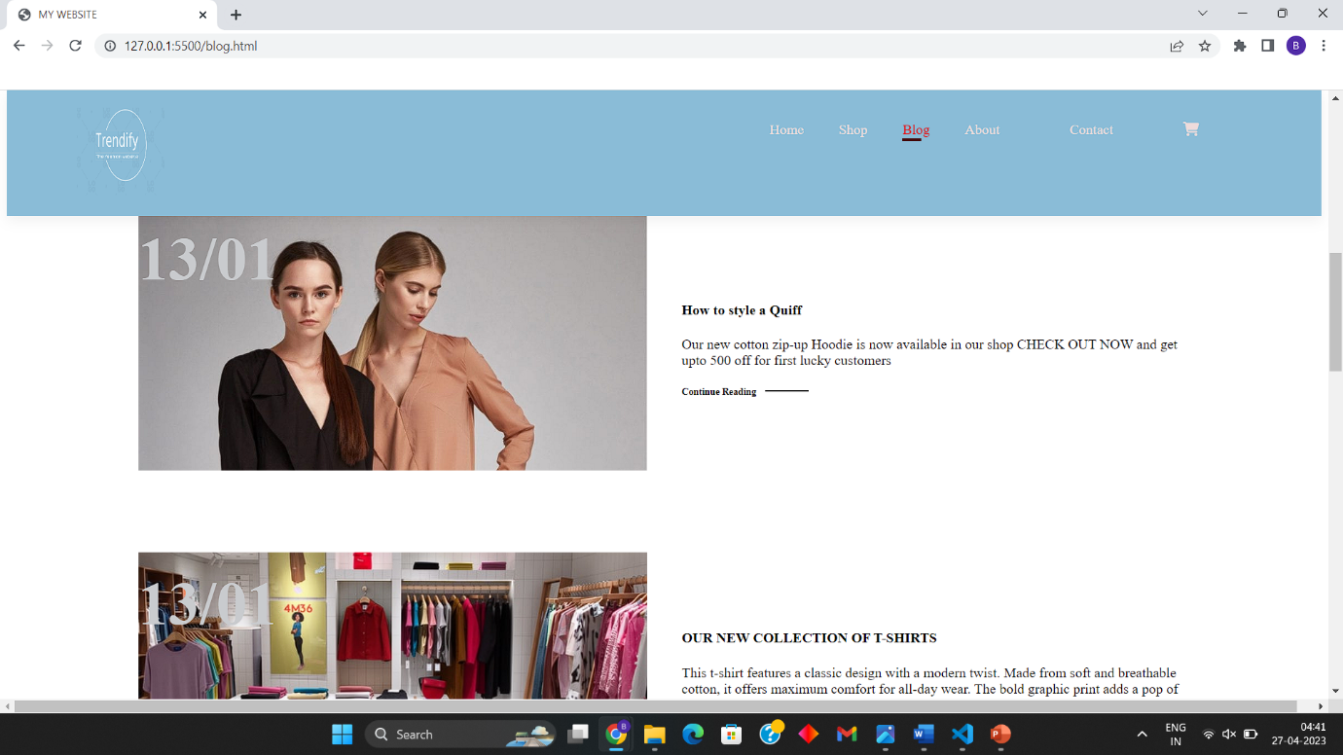

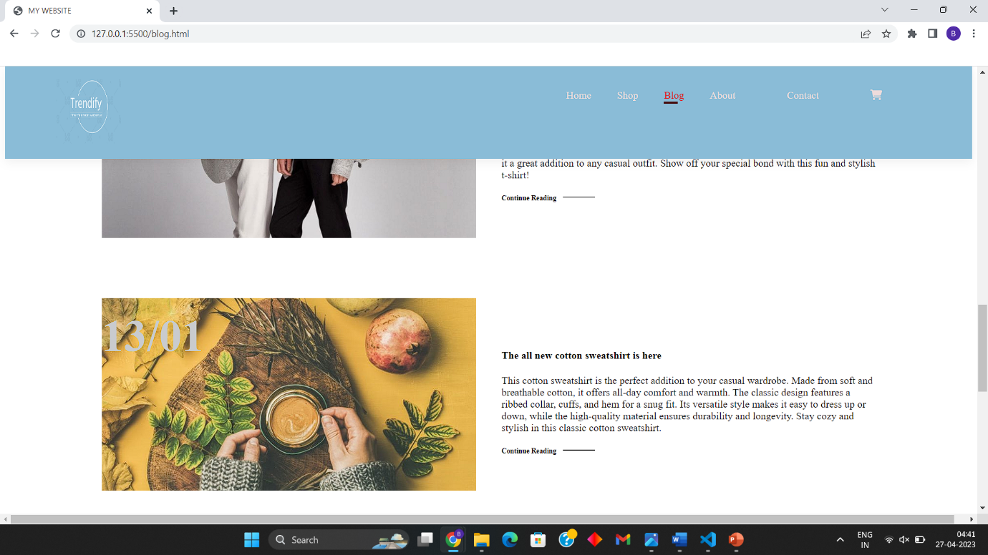

**About Us Page**

The image below shows the About Us page which includes the information of the website

And its products.

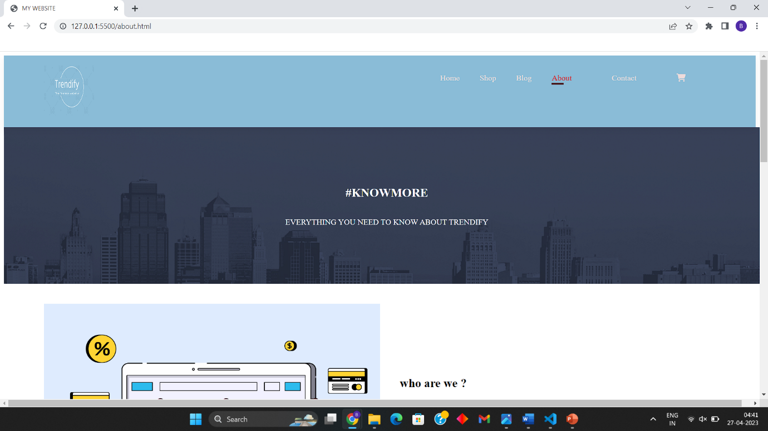

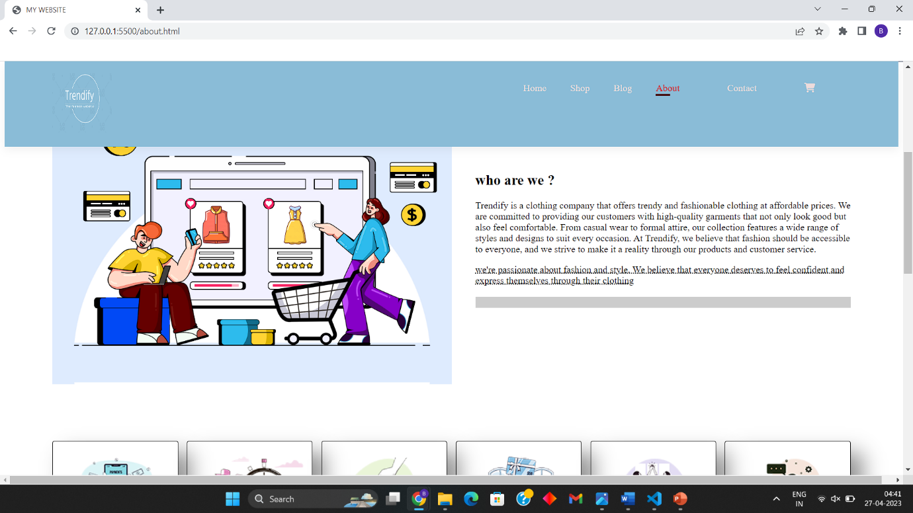

**Contact Us Page**

The image below shows the contact us page which mainly includes the information of the offline stores (if available). It also includes a map for the access of the location.

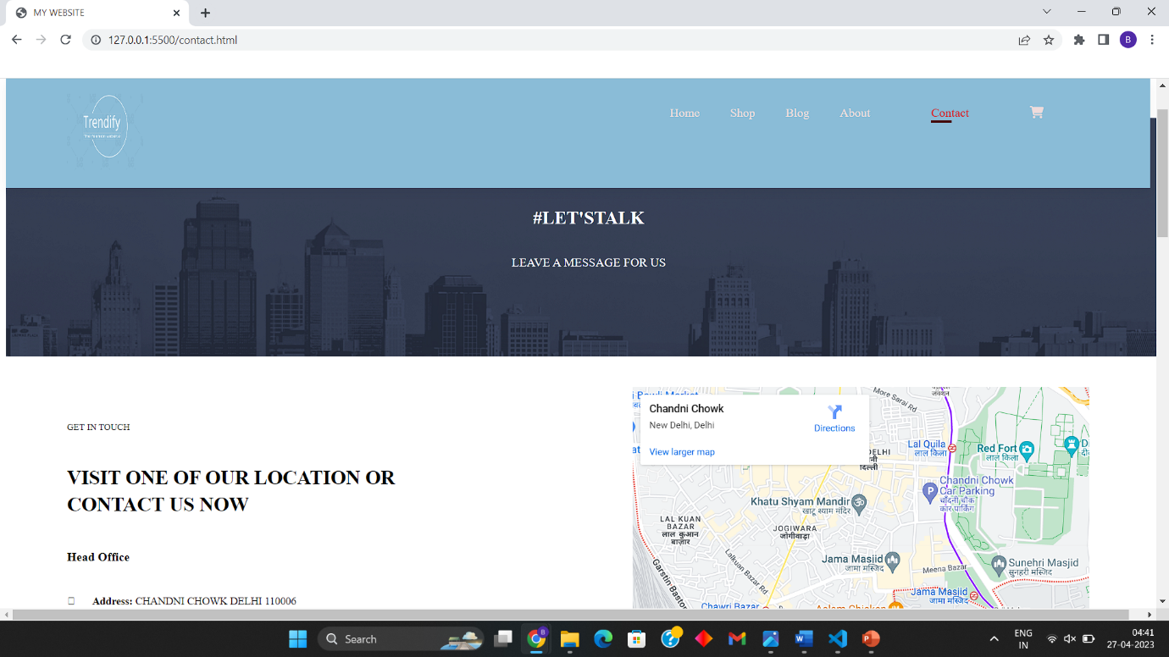

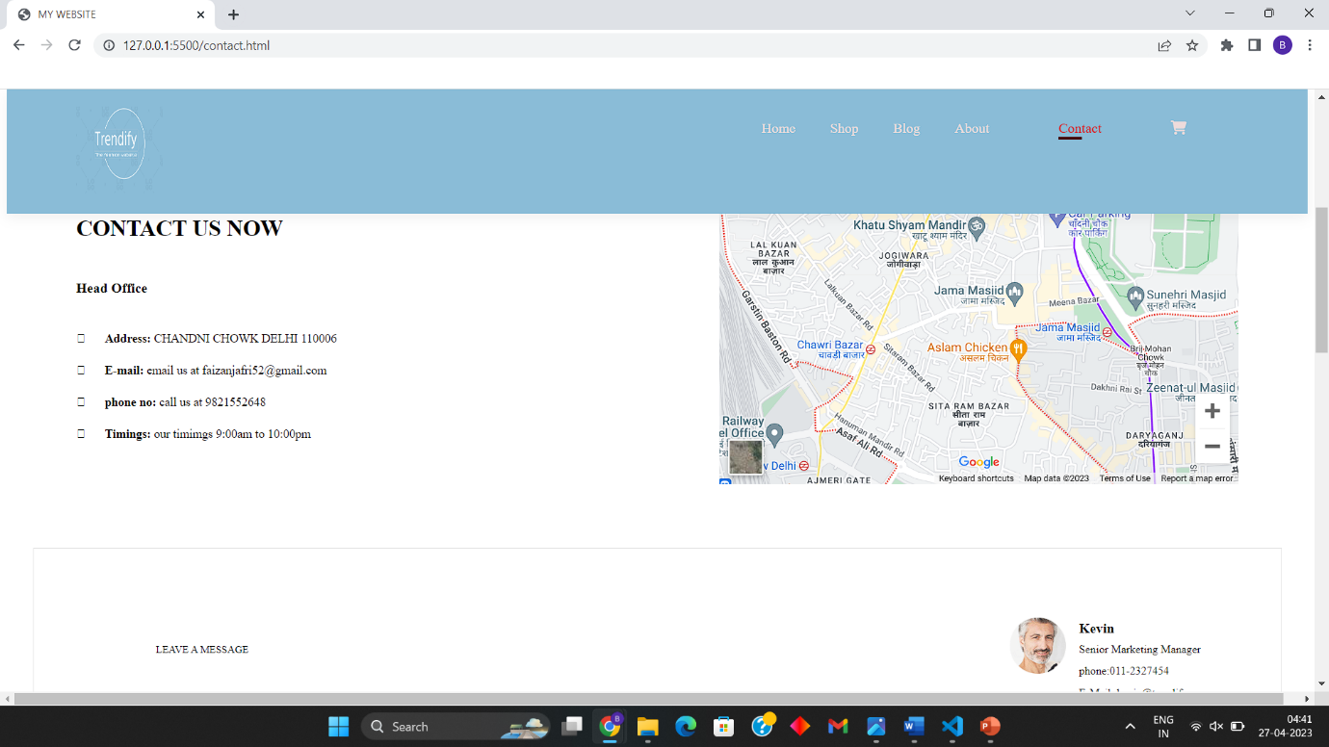

**Get In Touch Form**

The image below shows the GET IN TOUCH form. It is the main source through which the customer can contact the website owner. After filling the form all the details are sent to the owner through an email

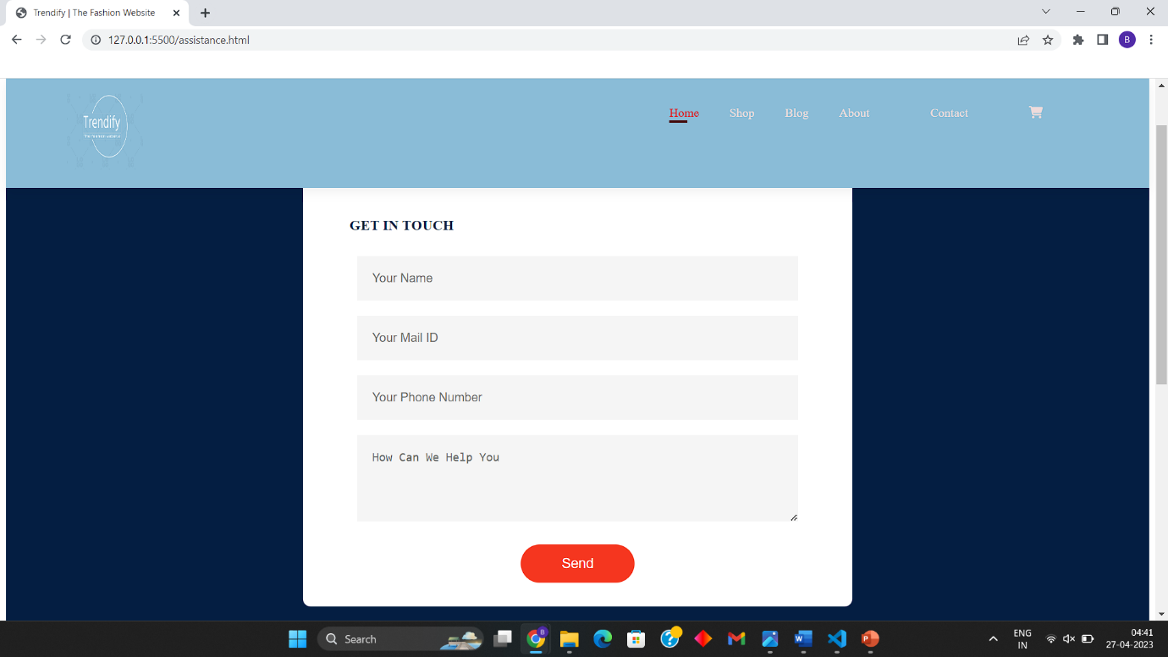

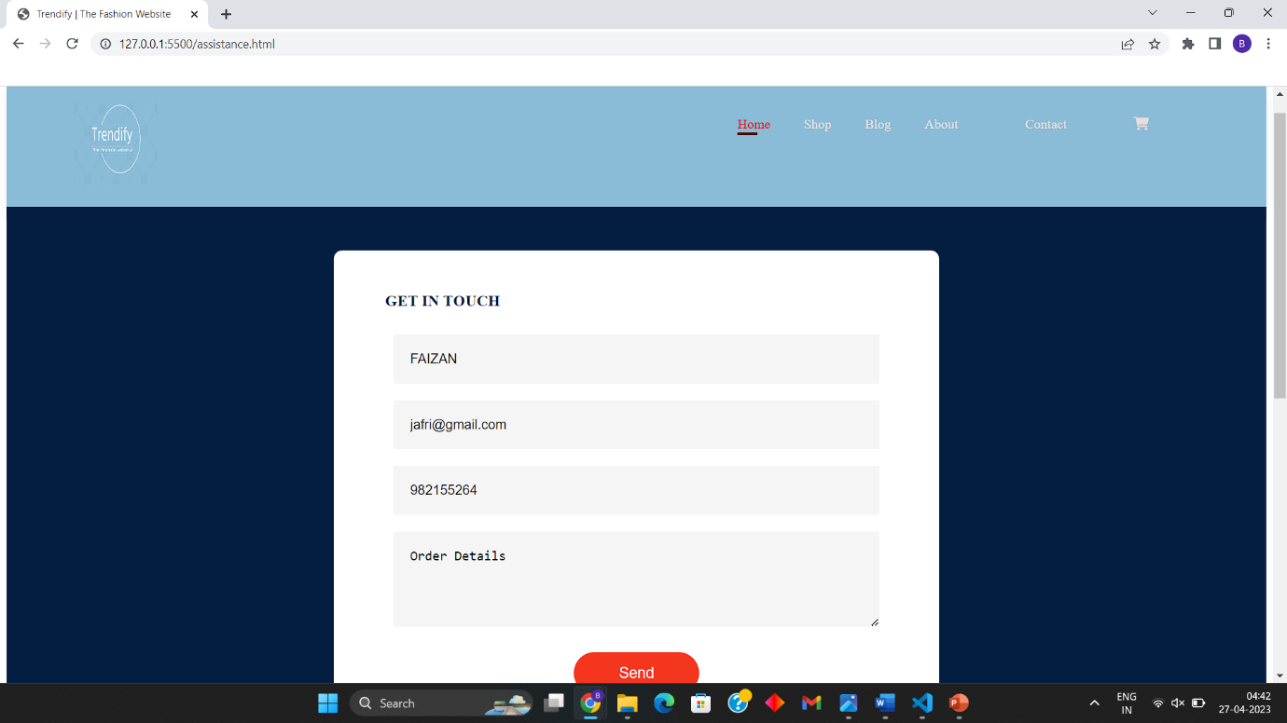

The screenshots below shows the images of the data received by the owner in the form of E-Mail.

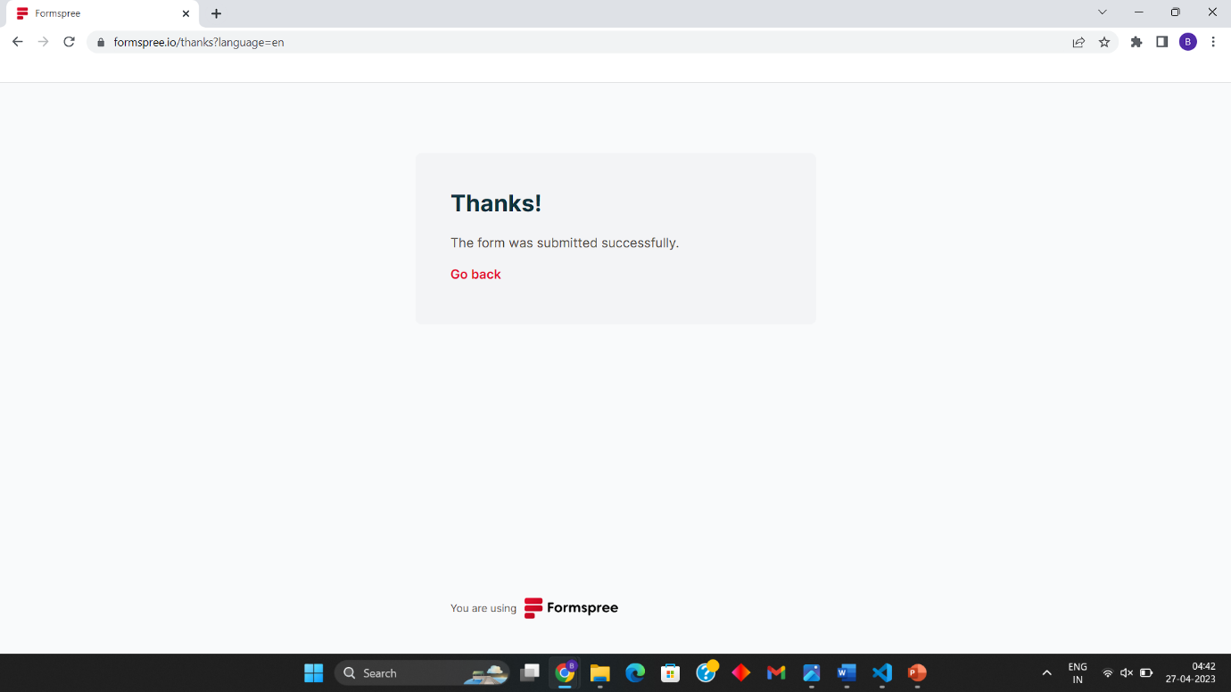

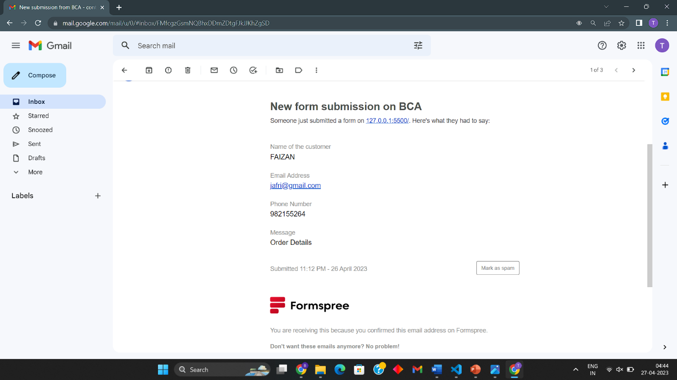

**CHAPTER-5**

CONCLUSION

In conclusion, Trendify has been a successful e-commerce website that has provided customers with a visually appealing and user-friendly platform to purchase their favorite clothing products. The website has been able to offer a large number of products for both men and women, which has been a major advantage for customers looking for a wide range of options.

Although the website has been successful, there are still limitations and future scope for improvement. One major limitation is the lack of a proper backend system for storing data, which could result in loss of information and inconvenience for the customers. However, the team behind Trendify has plans to address this limitation by building a proper backend system that can store data securely.

Another limitation is the absence of a payment system, which has made it difficult for customers to make purchases easily. However, the team behind Trendify is working on providing payment facilities to customers in the near future. Additionally, there is a need for a proper login page to make it easier for customers to track their orders and manage their profiles.

Looking towards the future, Trendify has a lot of scope for improvement and growth. The addition of new pages and features such as a blog section could enhance customer engagement and make the website more informative and interactive. There is also a need to expand the product range and include more brands to cater to the diverse needs of customers.

Furthermore, the website can benefit from an improved social media presence and online marketing strategies to reach a wider audience and increase brand awareness. The team behind Trendify can also explore the possibility of integrating artificial intelligence (AI) and machine learning algorithms to provide personalized recommendations to customers and enhance their overall shopping experience.

In conclusion, Trendify has been a successful e-commerce website that has provided customers with a visually appealing and user-friendly platform to purchase their favorite clothing products. However, there is still room for improvement and growth, and the team behind the website is committed to addressing the limitations and exploring future opportunities to enhance the overall shopping experience for their customers.

LIMITATAION AND FUTURE SCOPE

**LIMITATIONS:**

1. The website currently lacks a proper backend system for storing data, which could impact the scalability of the website as the number of users and products increases.
2. The website does not have a payment system integrated, which limits the ability of users to make purchases.
3. There is currently no login page, which limits the ability to create personalized user accounts and keep track of user data.
4. The website may experience downtime or slow page loading times if there is an influx of traffic, which could lead to frustration for users.
5. The website does not currently have a mobile app, which limits the ability of users to shop on-the-go.
6. The website may be limited in terms of the number of products that can be added due to server capacity and storage limitations.
7. The website currently only offers clothing items for men and women, which limits the potential audience and target market.
8. The website currently does not have a system for offering discounts or promo codes, which could limit the ability to attract customers.
9. There may be limitations in terms of shipping options, such as not offering international shipping, which could limit the potential audience.
10. The website may be limited in terms of marketing and advertising, which could impact the ability to attract new customers and increase brand awareness.

**FUTURE** **SCOPE:**

1. Implementation of a proper backend system to improve data storage and scalability.
2. Integration of a secure payment system to allow users to make purchases directly on the website.
3. Development of a login page and personalized user accounts to improve user experience and data tracking.
4. Optimization of website performance and loading times to improve user satisfaction.
5. Creation of a mobile app to offer a more convenient and accessible shopping experience.
6. Expansion of product offerings beyond clothing items to attract a wider audience.
7. Implementation of a discount and promo code system to attract new customers and retain existing ones.
8. Expansion of shipping options to include international shipping and faster delivery options.
9. Development of a social media marketing strategy to increase brand awareness and attract new customers.
10. Incorporation of user feedback and suggestions to continuously improve the website and meet the needs of the target audience.

BIBLIOGRAPHY

Following sources helped me to complete the project:

1. "HTML Tutorial for Beginners" by Programming with Mosh, YouTube, <https://www.youtube.com/watch?v=UB1O30fR-EE>
2. "CSS Tutorial for Beginners" by The Net Ninja, YouTube, <https://www.youtube.com/watch?v=1Rs2ND1ryYc>
3. "JavaScript Tutorial for Beginners" by FreeCodeCamp.org, YouTube, <https://www.youtube.com/watch?v=PkZNo7MFNFg>
4. "HTML Tutorial" by W3Schools, <https://www.w3schools.com/html/>
5. "CSS Tutorial" by W3Schools, <https://www.w3schools.com/css/>
6. "JavaScript Tutorial" by W3Schools, <https://www.w3schools.com/js/>
7. Tutorial by FormSpree

<https://formsubmit.co/bootstrap-tutorial/>

1. "jQuery Tutorial" by TutorialsPoint, <https://www.tutorialspoint.com/jquery/>
2. "Codecademy" by Codecademy, <https://www.codecademy.com/>

These sources have been helpful in learning and implementing HTML, CSS, and JavaScript in the development of the Trendify e-commerce website.